# Section1: Write a singleton class. Confirm that singleton class cannot be inherited.

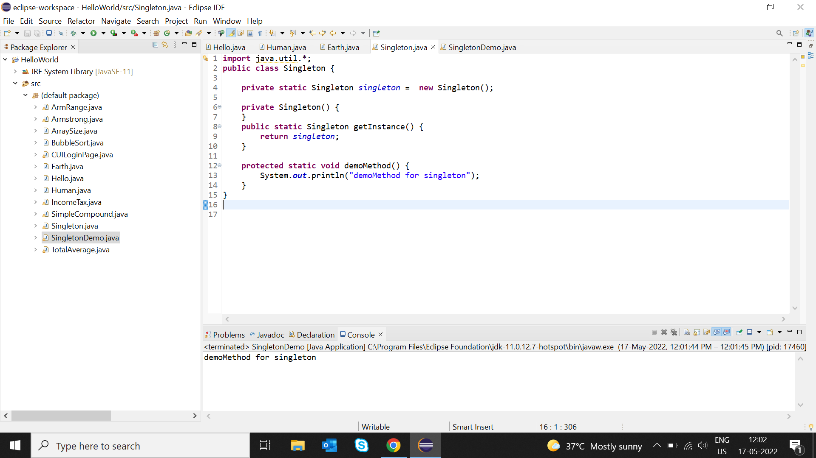

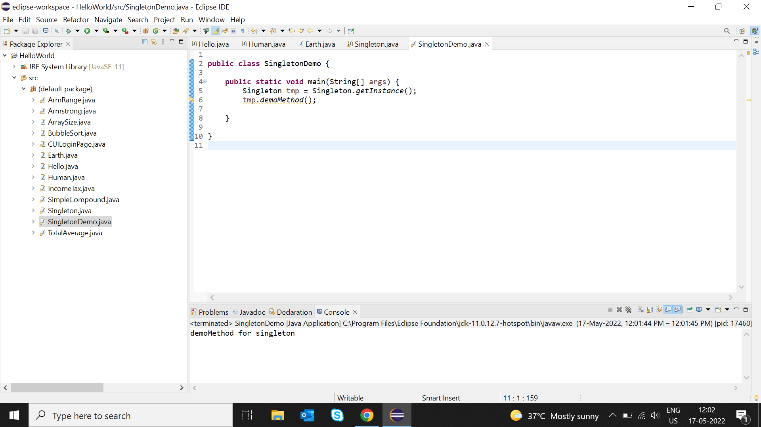

Section2: Write a program that describes the hierarchy of an organization. Here we need to write 3 classes Employee, Manager,& Labour where Manager & Labour are the sub classes of the Employee. Manager has incentive & Labour has overtime. Add the functionality to calculate total salary of all the employees. Use polymorphism i.e. method overriding.

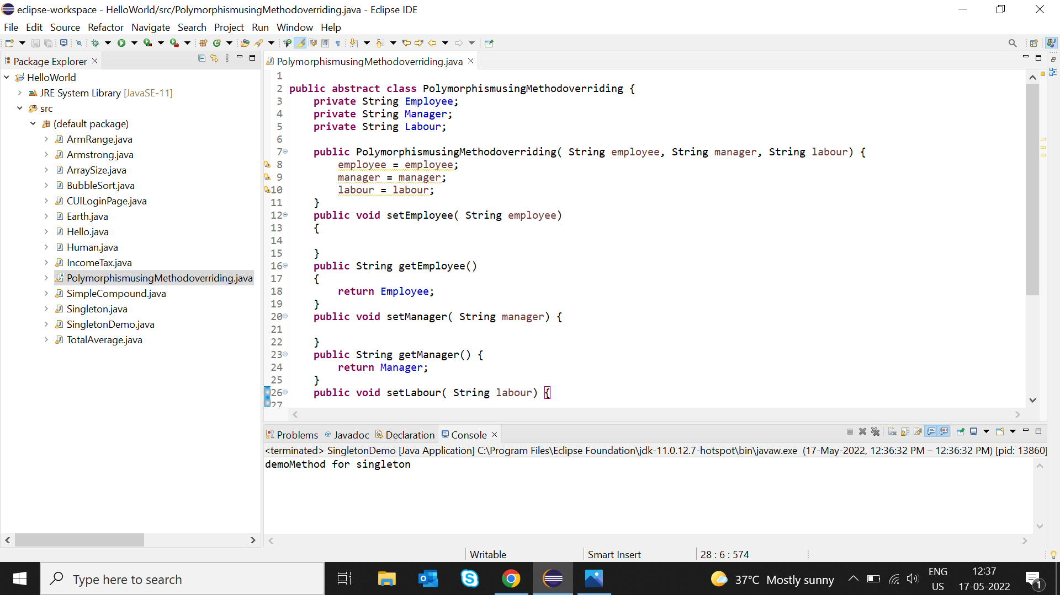

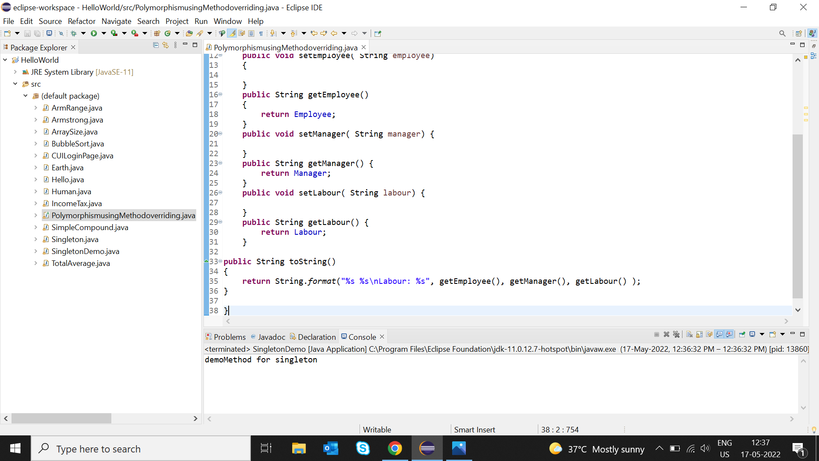

Section3: Write a program to consider saving & current account in the bank. Saving account holder has ‘Fixed Deposits’ whereas Current account holder has cash credit. Apply polymorphism to find our total cash in the bank.

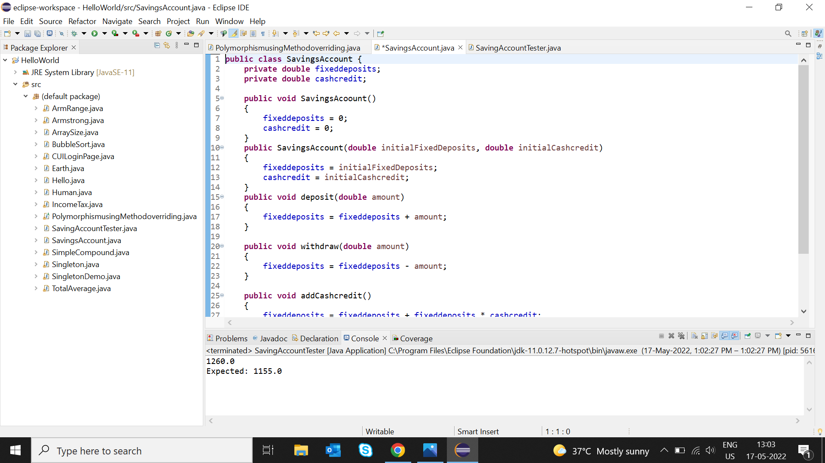

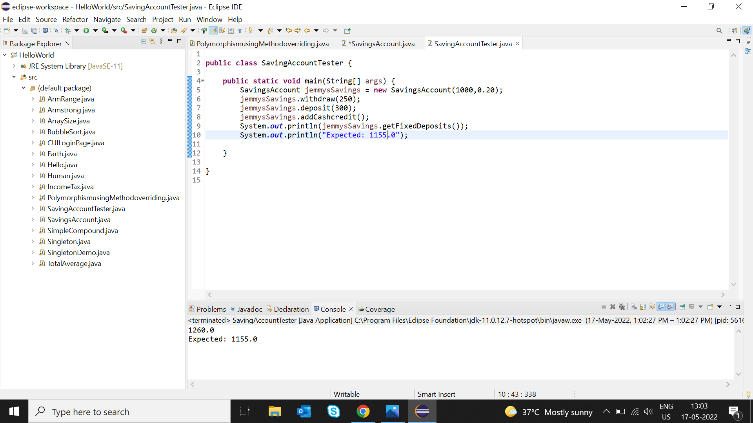

Section4: Write the classes Line, Rectangle, Cube etc. & make the Shape as their base class. Add an abstract draw() method in the class Shape & draw all shapes.

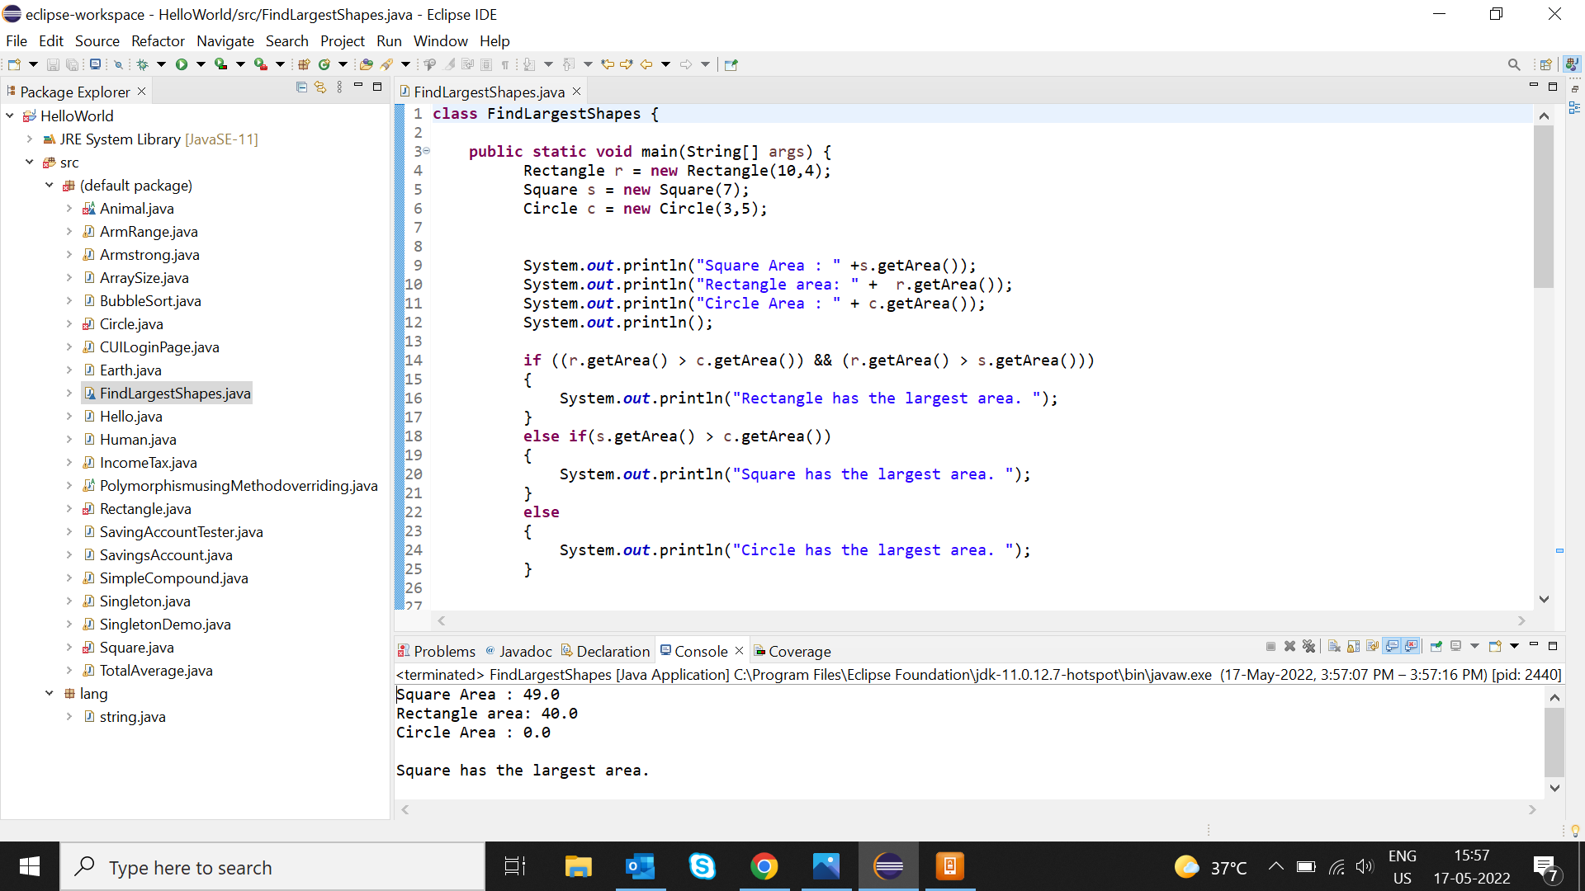

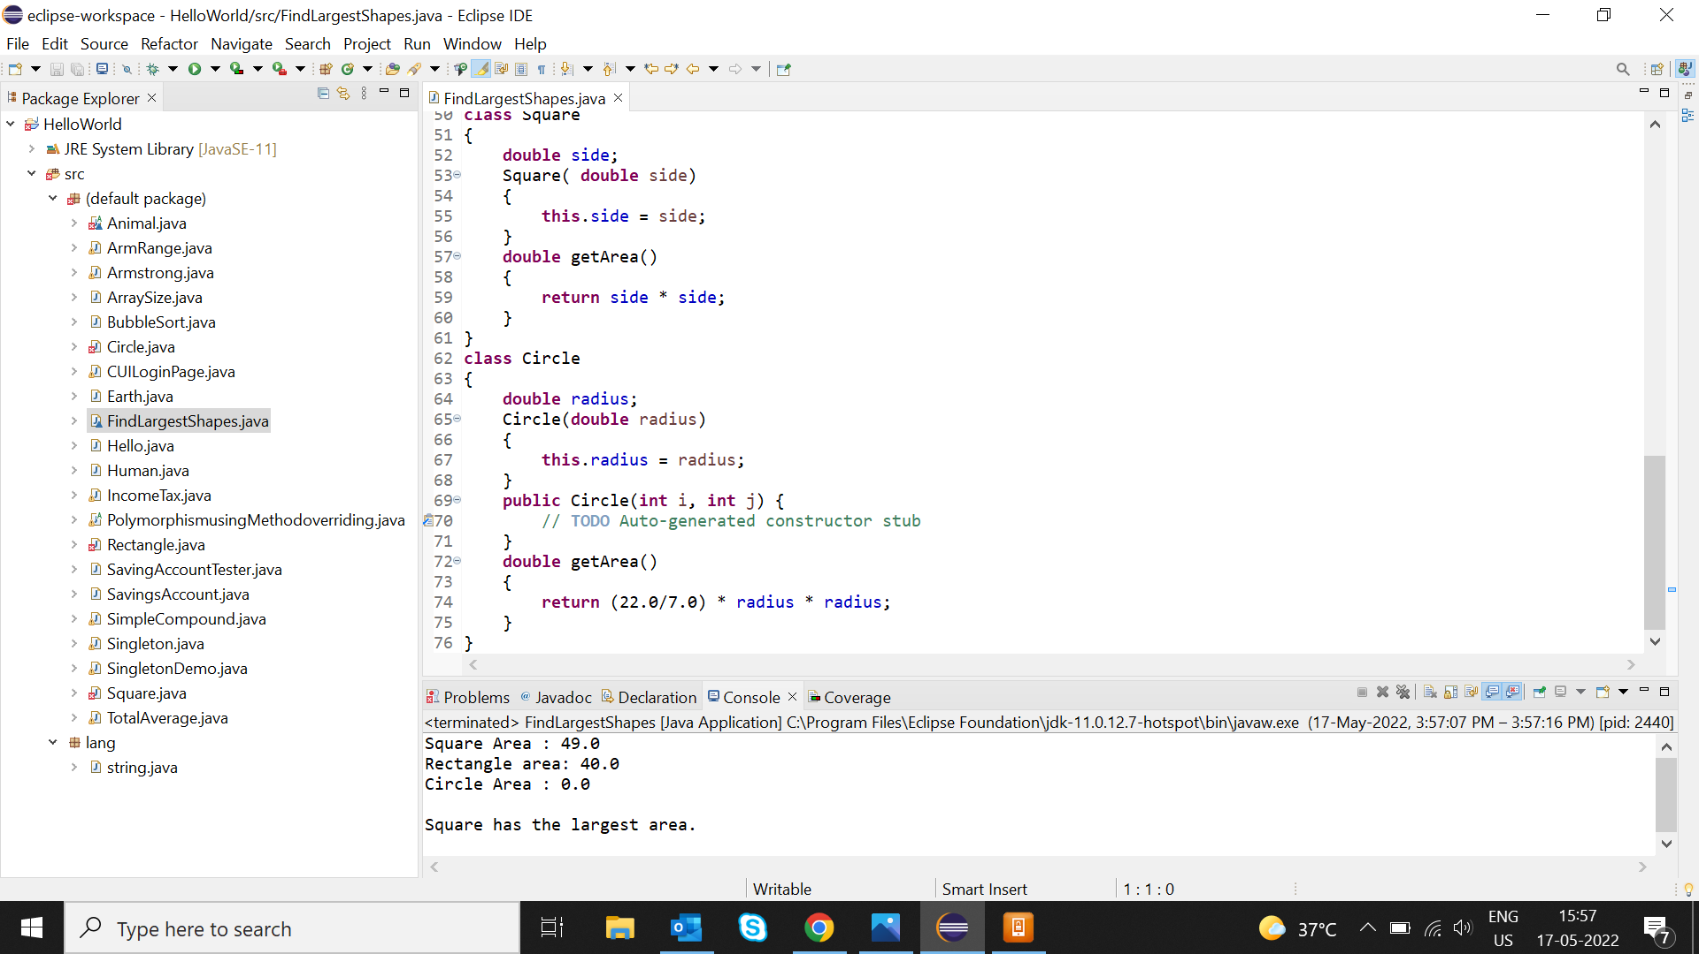

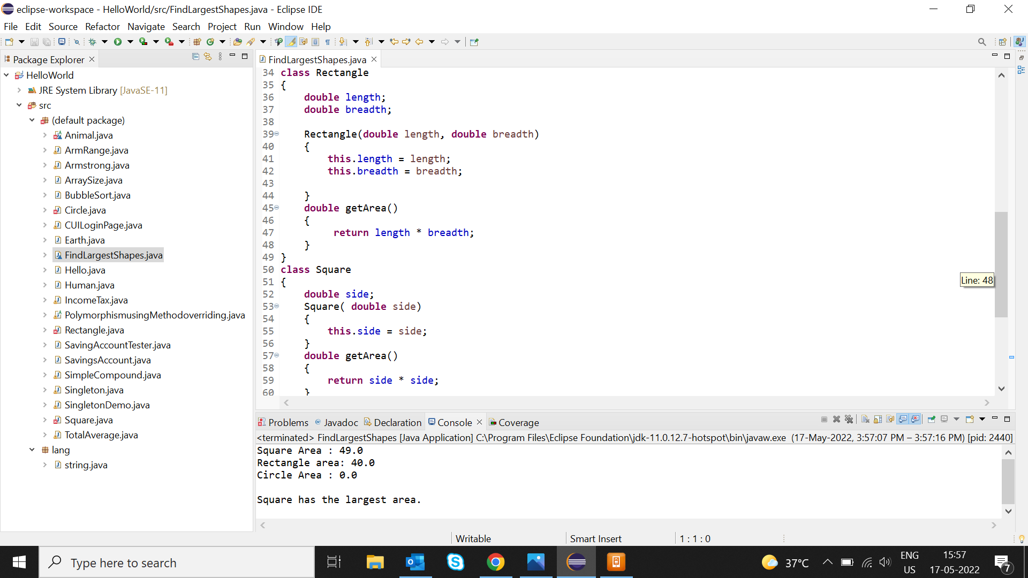

Section5: Write an abstract class ‘Persistence’ along with have an abstract method persist() which will be overridden by its subclasses. Write a client who gets the persistence object at runtime and invoke pesist() method on it without knowing whether data is being saved in File or in Database.

Section6: Develop an application for Dessert shop. The application should allow owner to add items like Candy, Cookie or IceCream in the shop storage. Also customers should be able to place an order. The currency conversion rates are:

1 dollar = 60 rupees.

1 euro = 70 rupees.

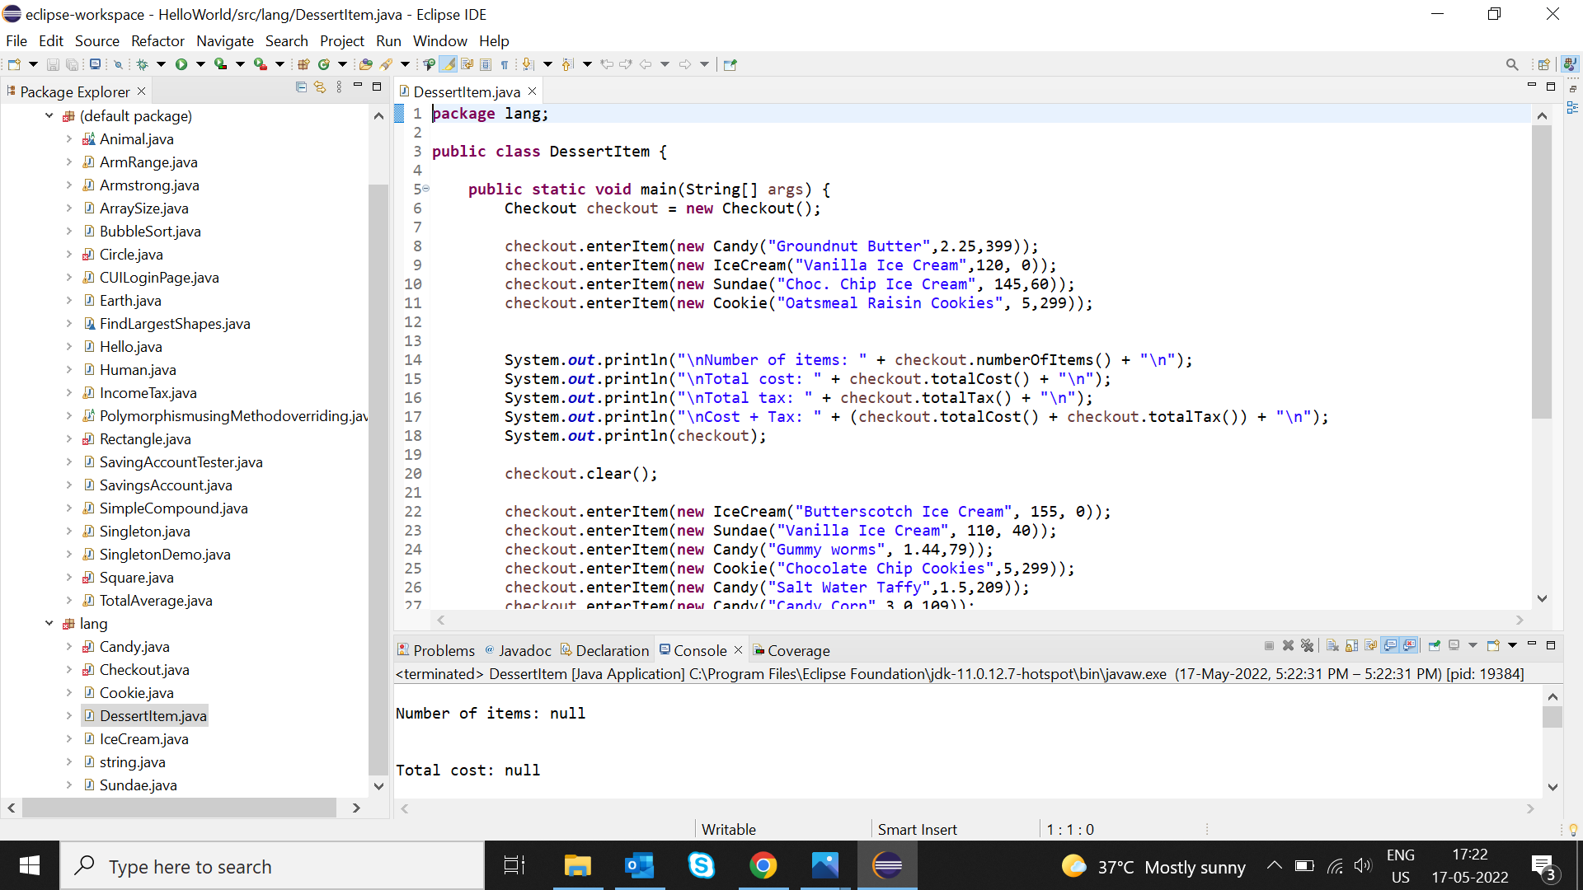

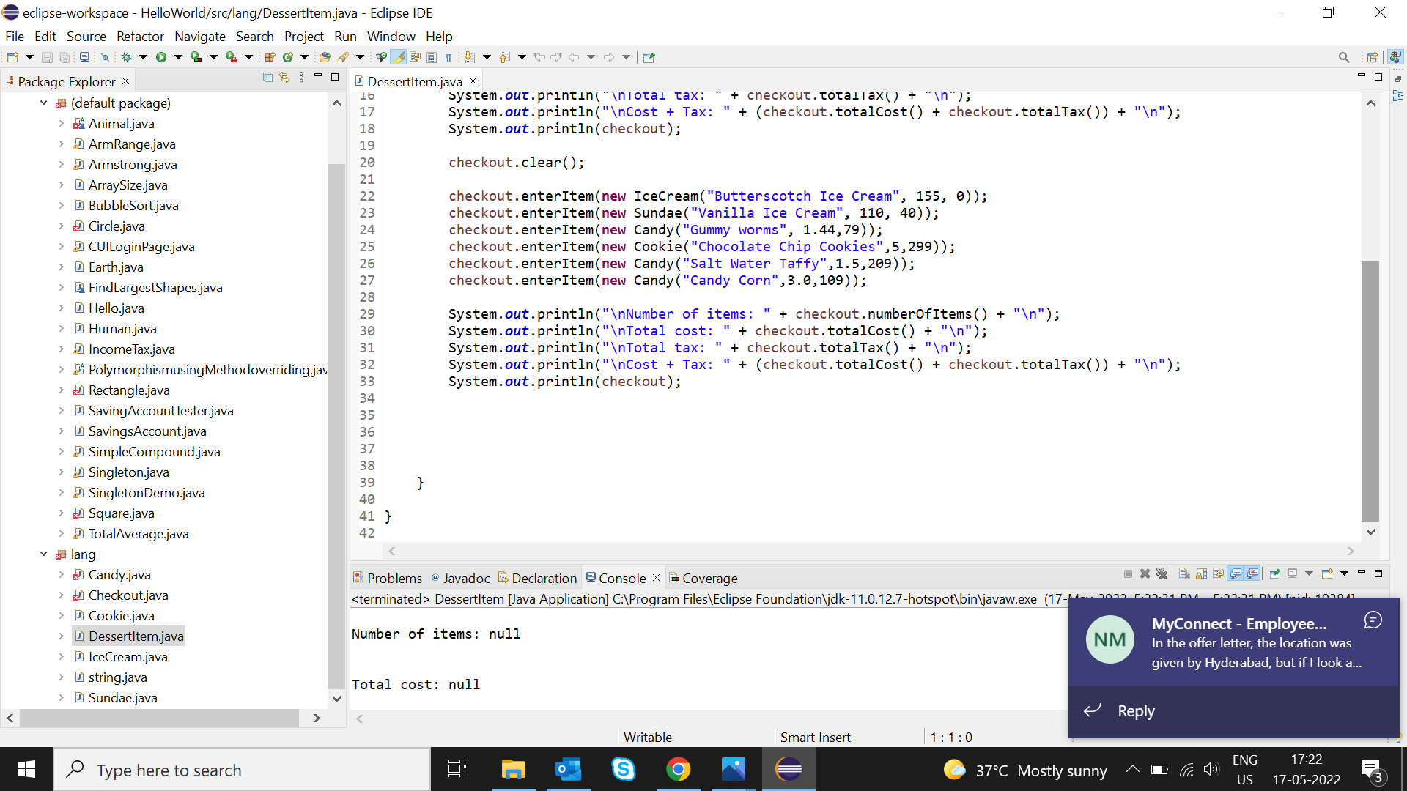

Persistence

7)Abstract

